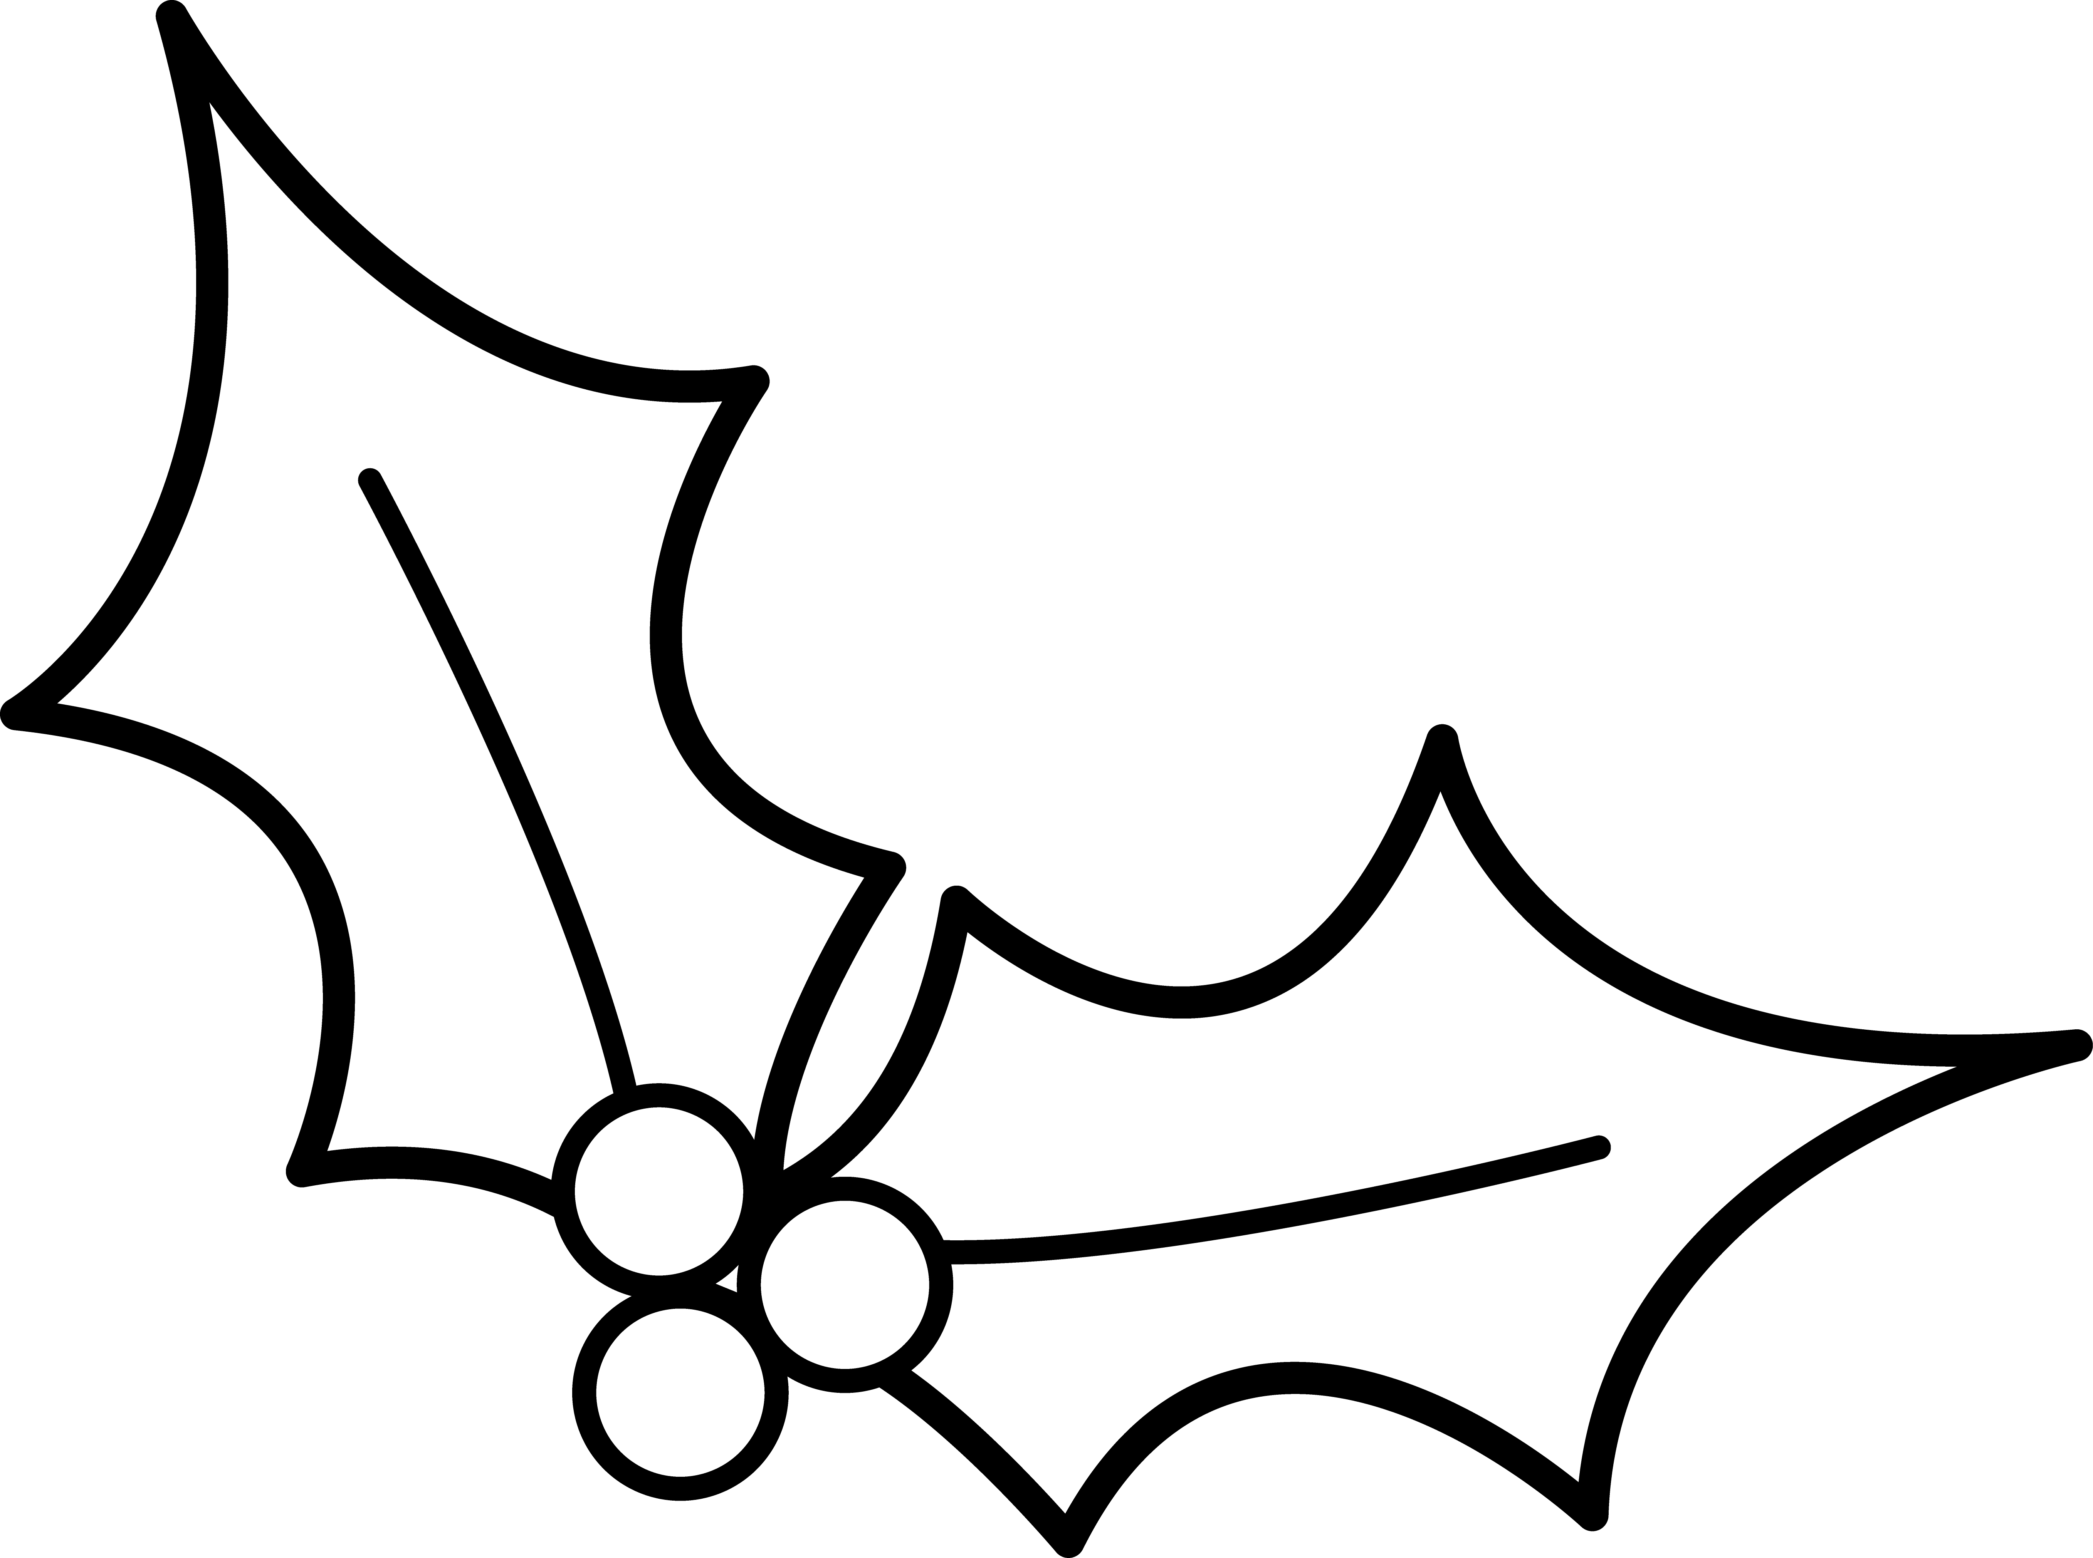

We would like to collect a variety of items and so have included a guideline for each year group. Please do not feel that you have to stick rigidly to these suggestions.

**NURSERY**  CHOCOLATES/BISCUITS/SWEETS

eg: good quality chocolates, truffles, boxes of biscuits, tins of sweets / biscuits.

**PRIMARY ONE**  CHOCOLATES/BISCUITS/SWEETS

eg: good quality chocolates, truffles, boxes of biscuits, tins of sweets / biscuits.

**PRIMARY TWO** SMALL GIFTS

eg: small gifts for mums and dads that the children can buy on the day and help wrap for parents, grannies, grandas. Toiletries, bath smellies, slippers, gloves, books, trinkets, plants etc.

**PRIMARY THREE**  **CHRISTMAS STALL**

eg: tree decorations, festive napkins, wrapping paper, Christmas cards

**All items to be left with the class teacher or in the school office by Friday 24th November.**

# PRIMARY FOUR ARTS AND CRAFTS

eg: crayons, pencils, felt-tips, paints and brushes, stencils, glitter, stickers, craft boxes, highlighters, sharpeners, erasers, black boards, chalks and pencil cases.

**PRIMARY FIVE**  NEW TOYS

eg: soft toys, jigsaws, games, dolls, cars etc ranging in price of £5 or less and/or new but unused toys, eg: unused but new toys given as gifts or presents.

**PRIMARY SIX**  CANDLES

eg: Christmas/seasonally scented candles in particular please as these are always hugely popular.

**PRIMARY SEVEN**  WINE/SPIRITS

eg: wines and spirits, mulled wine. We ask if possible that the bottles of wine and spirits are placed in a gift bag.

**We would be grateful for any donations for the raffle prizes.**

**We would also welcome tray bakes, cakes etc. for the home bake stall. We would be grateful if these did not contain nuts. This is in keeping with St. Bride’s “no nut policy”. If donating cakes or buns, please put your name on your tubs so we can return them.**

**Thank you all once again for supporting our Christmas Fair. We hope to see you all on the day. We know it will be a great day for all in our wonderful school community.**

# 





Raffle tickets have been sent home with all children. We have some amazing prizes this year including:

* An IPad Mini, Game of Thrones Monopoly and Cludo
* A girl’s and boy’s bike from Decathlon- can be exchanged
* Dart board, body board, football nets
* Two scooters
* Vouchers for Doyen, The French Village, Café Mauds, Corries, Slims, Bluebird and Me, Tescos and many more
* A gorgeous tie from Hugo Thomas
* Clarins Sets
* Hampers
* Two drinks set with glasses

There are lots more prizes. If you are not in you can’t win!

### ST BRIDE’S CHRISTMAS FAIR

### Sunday 25th November 2018

### 2 – 5pm

Dear all,

Thank u to those of you who have already volunteered to work at the fair, and to those who have donated prizes and goodies for the stalls. There is plenty of time to send items in.

This is one of the highlights of the school year and is one of the main fundraisers. A list of suggested donations for each year group is listed overleaf. Without your support the school could not provide many of the facilities our children enjoy. So thank you so much for your continued support.

The fair will include:

**PRIZE DRAW** – Tickets have been sent home with every pupil. Some of our fantastic prizes are on display in the Derryvolgie foyer and others are listed on the back page. Additional tickets are available from the school office and at the fair. The Prize Draw will take place at 4.30pm at the Fair.

**KIDS ZONE** - The Christmas Fair will continue to focus on entertainment and fun for our children. The Kids Zone includes Christmas art stalls, reindeer food, design a cookie stall etc. In the yard there will be a **penalty shoot zone.**

**SANTA’S GROTTO**- Our Santa’s Grotto is back, with all the magic for our little ones. Please remember that the queue for Santa can get very long so please call in to see Santa early. **Santa’s Grotto must close at 4pm** as he has to return to Mrs. Claus.

**GIFT ROOM:** In the front P1 foyer you will find a gift stall where kids can go to choose presents to buy for mums, dads, grannies and grandas. They can get them wrapped there too!

**JUNGLE SHOW** – This show promises to be a delight for kids big and small. Live animals such as chameleons, lizards, snakes, spiders, frogs and scorpions will be included in this demonstration and available for touch and feel. This can be found in the nursery.

**MAIN HALL** – Decorations, arts and crafts, toys, home bakes, wrapping paper etc. can all be found in the main hall.

**CANTEEN -** You can pop into the canteen for a cup of tea, a tray bake and a chat. The children this year can buy a **hot dog** and a drink.

We need more volunteers to set up and run the fair including on the day. If you can help with set up on Friday from 1.15 pm onwards (St Bride’s children can be minded in Mrs. Merron’s classroom between 2 and 4pm) please come along to the assembly hall. If you wish to help out on the day, please let Jackie know in the office or let the PTA know through their Facebook page. It would be great if some people could just with the clean-up from 5pm to 6pm.

# VOLUNTEERS AND TRAYBAKES

# PRIZE DRAW TICKETS

# Ho! Ho! Ho! One Week To Go!

**PTA**

**CHRISTMAS FAIR**

St. Bride’s PTA Belfast

SUNDAY 25TH NOVEMBER 2018